ASSIGNMENT 22

Name : Akanksha Joshi

Roll No : B038

Batch : 3

Div : BTech CS B

-------------------------------------------------------------------------------------------------------------------------

Q.Consider the list of courses opted by a Student "John" and available electives at ABC Training Institute:

courses = ("Python Programming", "RDBMS", "Web Technology", "Software Engg.")

electives = ("Business Intelligence", "Big Data Analytics")

Write a Python Program to satisfy business requirements mentioned below:

1. List the number of courses opted by John.

2. List all the courses opted by John.

3. John is also interested in elective courses mentioned above. Print the updated tuple including electives.

Source Code

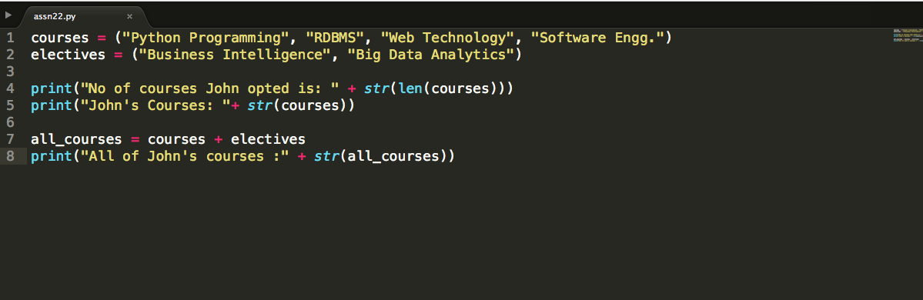

Output

No of courses John opted is: 4

John's Courses: ('Python Programming', 'RDBMS', 'Web Technology', 'Software Engg.')

All of John's courses :('Python Programming', 'RDBMS', 'Web Technology', 'Software Engg.', 'Business Intelligence', 'Big Data Analytics')